Prof. Dr. Salvador E. Venegas-Andraca
Tecnologico de de Monterrey, Campus Ciudad de Mexico
Speaker biography:
Salvador E. Venegas-Andraca is a scientist, consultant, and entrepreneur devoted to scientific research, technology development, technology transfer, and teaching. Salvador's work aims to understand the scientific and societal aspects of computation and to contribute to the economic development of modern society based on science and technology.

Salvador is the founder of quantum computing in Mexico. He is also the founder and Principal Investigator of the Unconventional Computing Lab (est. 2004), a professor of Computer Science at Tecnologico de Monterrey, and adjunct professor at the Faculty of Sciences of the National Autonomous University of Mexico (UNAM). Also, Salvador is an Associate Editor of the Quantum Information Processing journal (Springer) and a member of the Quantum Computing Network of the World Economic Forum.

Salvador holds a DPhil in Physics and an MSc by research in Computer Vision, both awarded by the University of Oxford, as well as an MBA (Hon) and a BSc (Hon) in Digital Electronics and Computer Science, both awarded by Tecnológico de Monterrey. In 2008, Salvador was a postdoctoral fellow at Harvard University's Faculty of Arts and Sciences.

Salvador is a leading scientist in the field of quantum walks, co-founder of the field Quantum Image Processing, and his research interests include quantum algorithms, quantum walks, the analysis of biological information via quantum algorithms, quantum machine learning, quantum image processing, classical and quantum cybersecurity, and the analysis of NP-hard and NP-complete problems. Salvador has supervised several undergraduate (BSc) and graduate (MSc, PhD) students whose research efforts have been focused on quantum science and technology.

Salvador is the author of "Quantum Walks for Computer Scientists" (Morgan and Claypool, 2008), the first book ever written on the scientific field of quantum walks, and co-author of "Quantum Image Processing" (Springer, 2020), the first book ever written fully focused on storing, processing, and retrieving visual information using quantum mechanical systems. He has published more than 60 scientific papers, with over 3,000 citations in the Web of Science. Furthermore, Salvador has coauthored twelve white papers and insight reports on quantum technology and cybersecurity published by the World Economic Forum. Since 2020, Salvador has been included in the World's Top 2% Scientists lists for both career-long and single-year impact.

Salvador has delivered plenary talks, keynote talks, seminars, tutorials and other courses in Argentina, Brazil, Canada, Colombia, Egypt, Germany, Japan, Mexico, Peru, El Salvador, Saudi Arabia, United Arab Emirates, The United Kingdom, The United States of America, Uruguay, and The Vatican. He has also co-organized conferences, workshops and tutorials in Mexico, The United Kingdom, and The United States of America. Salvador has been a Visiting Professor at Harvard University, the National Autonomous University of Mexico, the National Polytechnic Institute (Mexico), Yucatan Autonomous University (Mexico), del Valle University (Colombia), Sergio Arboleda University (Colombia), Bahia Blanca University (Argentina), and Montevideo University (Uruguay).

Salvador has received several awards for his scientific achievements, among them: fellow of the Mexican Academy of Sciences, Senior Member and Distinguished Speaker of the Association for Computing Machinery, fellow of the Mexican Academy of Computer Science, member of the Mexican Society for the Public Communication of Science, Level 3 (physics and mathematics) at Mexico’s National Network of Researchers (SNII), Oxford University Chancellor Fund’s Award, Romulo Garza Award (2015), Outstanding Professor Award at Tecnologico de Monterrey (2021, 2022, 2024,2025), and Silver Medal at the British Council International Students Awards (2005).
Mtra. Elizabeth Burrola Meléndez
Centro de Innovación e Integración de Tecnologías Avanzadas

Senior Public Administration Executive with extensive experience in institutional management, internal control, auditing, budget evaluation, quality management systems, and higher education administration. Proven ability to strengthen organizational processes, improve operational efficiency, ensure regulatory compliance, and lead multidisciplinary teams toward achieving strategic objectives. Skilled in public sector governance, budget management, process improvement, and educational quality assurance.
Director Center for Innovation and Integration of Advanced Technologies - National Politechnic Institute 2024 to date.

Academic Director Technological University of Camargo 2021 – 2023

Technical Coordinator Ministry of Public Administration (Secretaría de la Función Pública) | 2021

EDUCATION
Master’s Degree in Administration Autonomous University of Chihuahua
Diploma in Competency Development for Educational Reform Implementation Pan-American Institute of Senior Business Management (IPADE)
Diploma in English Language Studies Tecnológico de Monterrey (ITESM)
Bachelor’s Degree in Public Accounting (Honors) Autonomous University of Chihuahua

Mtro. Orlando Daniel Avitia
Director Regional Zona Norte de CECyTECH
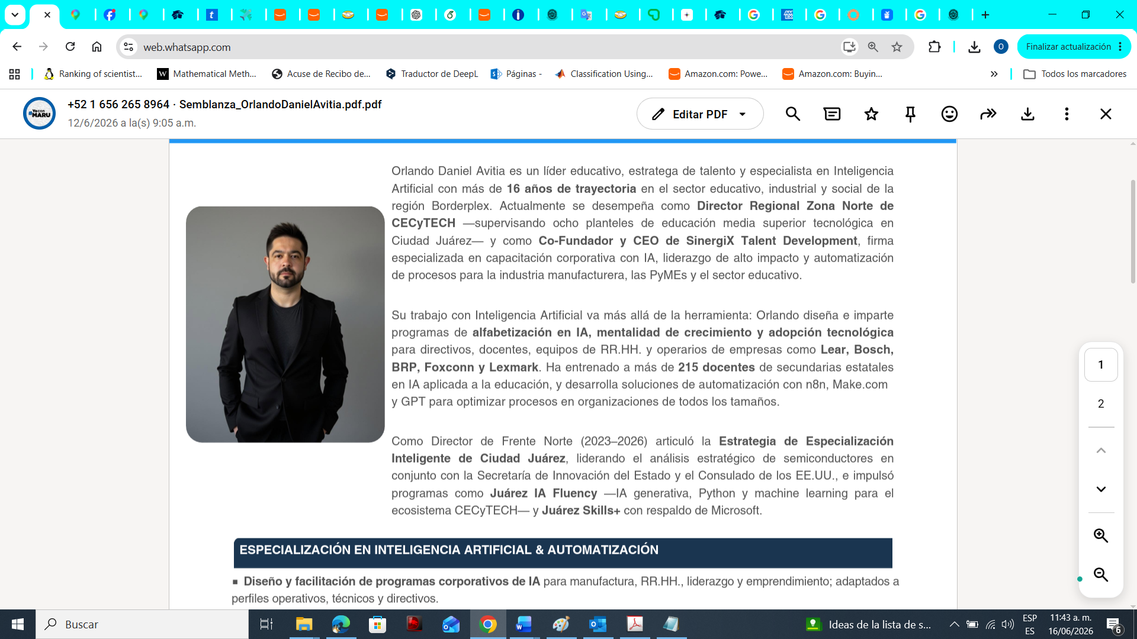

Orlando Daniel Avitia es un líder educativo, estratega de talento y especialista en Inteligencia Artificial con más de 16 años de trayectoria en el sector educativo, industrial y social de la región Borderplex. Actualmente se desempeña como Director Regional Zona Norte de CECyTECH —supervisando ocho planteles de educación media superior tecnológica en Ciudad Juárez— y como Co-Fundador y CEO de SinergiX Talent Development, firma especializada en capacitación corporativa con IA, liderazgo de alto impacto y automatización de procesos para la industria manufacturera, las PyMEs y el sector educativo. Su trabajo con Inteligencia Artificial va más allá de la herramienta: Orlando diseña e imparte programas de alfabetización en IA, mentalidad de crecimiento y adopción tecnológica para directivos, docentes, equipos de RR.HH. y operarios de empresas como Lear, Bosch, BRP, Foxconn y Lexmark. Ha entrenado a más de 215 docentes de secundarias estatales en IA aplicada a la educación, y desarrolla soluciones de automatización con n8n, Make.com y GPT para optimizar procesos en organizaciones de todos los tamaños. Como Director de Frente Norte (2023–2026) articuló la Estrategia de Especialización Inteligente de Ciudad Juárez, liderando el análisis estratégico de semiconductores en conjunto con la Secretaría de Innovación del Estado y el Consulado de los EE.UU., e impulsó programas como Juárez IA Fluency —IA generativa, Python y machine learning para el ecosistema CECyTECH— y Juárez Skills+ con respaldo de Microsoft.

Ing. Javier Acosta
Mechatronics Ai
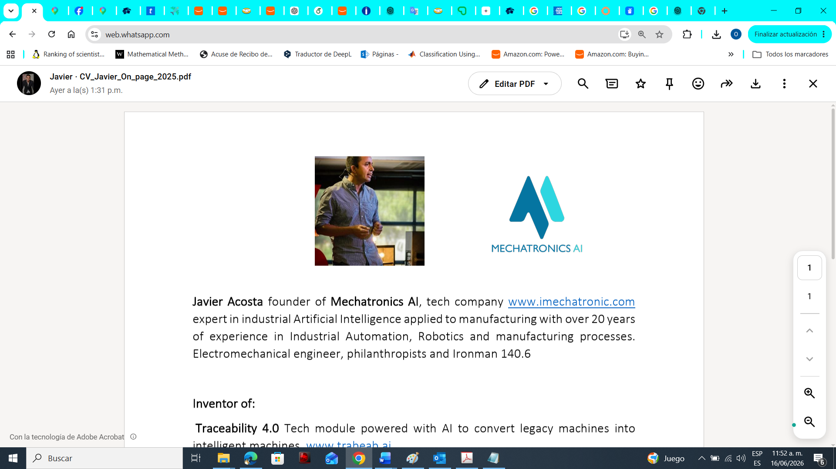
Founder of Mechatronics AI, a tech company (www.imechatronic.com). Expert in industrial Artificial Intelligence applied to manufacturing with over 20 years of experience in Industrial Automation, Robotics, and manufacturing processes, Electromechanical engineer, philanthropists and Ironman 140.6.

Inventor of: Traceability 4.0 Tech module powered with AI to convert legacy machines into intelligent machines (www.trabeab.ai).
ArVision Artificial Vision System to boost productivity and quality for manufacturing processes to track employees, materials, machinery behavior and Intelligent traffic Lights (www.arvision.ai).
Humantronic Humanoid arms to help in production lines, focused on manufacturing assemblies (www.humantronic.ai)

